

**COEN 6312**

**Model Driven Software Engineering**

**Deliverable-3**

**Project-Team**

|  |  |
| --- | --- |
| Name | ID No. |
| **Ganesh Santhar** | **40010625** |
| BhanuPrakash Ramineni | 27107838 |
| Jithin James | 27420854 |
| Rambabu Kunchala | 27262957 |
| Rakhi Ubriani | 27396333 |

**Index**

**1** **Introduction** 2

**1.1** **Purpose** 2

**1.2** **Scope** 2

**2** **Class Diagram** 2

**2.1** **Class Diagram for FlyinTravel (Flight Reservation System)** 3

**2.2** **Class Description** 4

**3** **Object Constraint language (OCL)** 6

**4** **References** 7

**5** **Appendix** 7

.

# **Introduction**

# **Class Diagram**

This Section will identify various classes involved in the Flight Reservation system in a UML class diagram. And It will describe each class individually with documenting the main contents of it say attributes and methods.

## **Class Diagram for FlyinTravel (Flight Reservation System)**

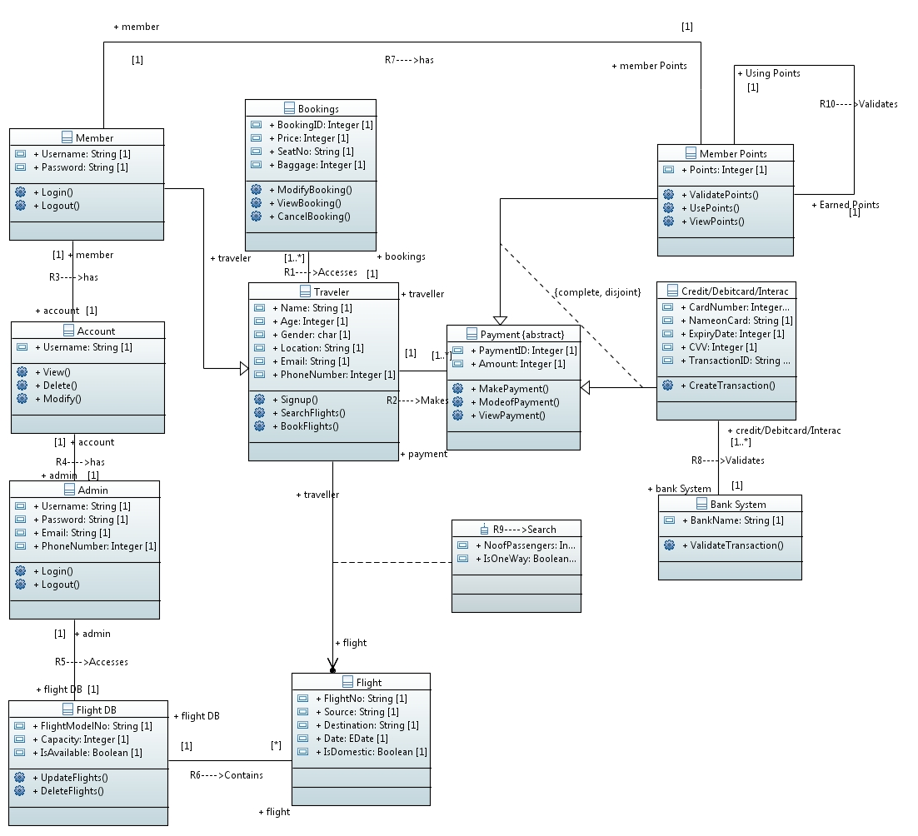

## **Class Description**

1. Traveler

The Traveler class is the base class for Member class. Traveler class abstracts all the objects of the traveler who is willing to book a flight using the system. This class contains the personal information of the traveler that is needed for booking. The attributes of the class will be Name, Age, Gender, Location, Email and PhoneNumber. The SearchFlights method is meant to retrieve the available flights of the flight class and the BookFlights method will book one of the retrieved flights. There is also a Signup method for creating an account in the system.

1. Member

The Member class has more properties and methods in addition to that of a Traveler class. They are represented with attributes and methods such as Username and Password, login and logout respectively. Member will accumulate points on bookings made. Each member will be identified uniquely by the attribute Username.

1. Account

The Account class contains accounts of Members and Administrator. Each Account is uniquely identified with the attribute Username. Its behavior is described by the methods such as View, Delete and Modify the account.

1. Admin

The Admin class will act as Administrator for the system. The Administrator can only update the flight database. This class is represented by properties such as Username, Password, Email and Phone Number. The behavior of the Admin is represented by methods such as login and logout.

1. FlightDB

The FlightDB class contains information of all the Flights. It has properties such as FlightModelNo, Capacity and IsAvailable. It Provides methods such as UpdateFlights and DeleteFlights to the Admin class. IsAvailable attribute gives the status of the flight, false indicates a cancelled flight.

1. Flight

The Flight Class shows available Flights to the Traveler that satisfies the search criteria. It is represented by attributes such as FlightNo, Source, Destination, Date, IsDomestic. A false in IsDomestic indicates an International flight.

# **Object Constraint language (OCL)**

1. The minimum age of traveler to access the system is 18 years.

Context Traveler

Inv: self.Age()>=18

1. An Account should be owned by a Member or Admin.

Context Account

Inv: self.R3->NotEmpty()

Or

self.R4->NotEmpty()

1. Booking should be successful only if the payment is made.

Context Traveler

Inv: self.R1.BookingID()->NotEmpty()

Implies

self.R2.PaymentID()->NotEmpty()

1. Admin must login to the Account to access the Flight database.

Context Admin

Inv: self. R5->NotEmpty()

Implies

self.R4->NotEmpty()

# **References**

1. Dr. AbdelWahab Class Notes on Class Modelling and OCL
2. Papyrus Class Diagram-

<https://wiki.eclipse.org/Papyrus_Starter_Guide#6.3.2.10_Create_a_new_class_diagram>